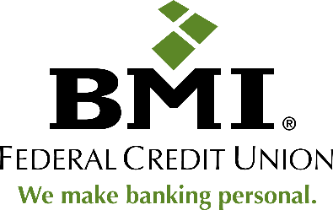

BMI Federal Credit Union

6165 Emerald Parkway

Dublin, Ohio 43016

**BMI Federal Credit Union Awarded Four Scholarships for the 2023 Jack Deibert Memorial Scholarship**

*Dublin, Ohio* (June 2, 2023) – BMI Federal Credit Union awarded four scholarships for the 2023 Jack Deibert Memorial Scholarship. This year, the Jack Deibert Memorial Scholarship provided four $2,000 scholarships to students in the community in pursuit of higher education. Grace Briles (SUNY Brockport), Molly Atkin (University of Cincinnati), Jacob Shafer (The Ohio State University), and Kate Ruff (The Ohio State University at Marion) were this year’s 2023 scholarship winners. Applications were accepted from February 2023 to April 2023, and winners were announced in June. Qualifying students for the scholarship must be a BMI FCU member in good standing at the time of submission, a high schooler senior graduating in 2022-2022, a student currently enrolled I a 2 or 4 year college or university (full or part-time), or a student attending a vocation school.

“The Jack Deibert scholarship is an amazing opportunity to support students in pursuit of higher education, “Vice President of Business and Community Development, Sarah Bach says. “We are proud of all four of these students and are excited to support them in their education journeys.”

**About BMI Federal Credit Union**

BMI Federal Credit Union is an award-wining financial institution in Central Ohio, delivering superior member service and competitive financial products. In addition to exceptional banking services, the Credit Union promotes financial wellness throughout the community with an award-winning Financial Education Program, charitable giving efforts, and credit union advocacy.

BMI Federal Credit Union has been recognized by the Columbus Dispatch for the 2018, 2019, 2020, 2021, and 2022 *CBUS Top Picks*, *The* *Charles B. Jenkins Legacy Award* winner in 2021, a *Best Employer in Ohio* for thirteen consecutive years by Crain’s Cleveland Business and Best Companies Group, and the 2021 CUNA Diamond Award winner for Crisis Management for their response to the COVID-19 pandemic. For more information about BMI Federal Credit Union visit www.bmifcu.org. Federally insured by NCUA. Equal Housing Lender. NMLS ID: 410831.

**Press contact:**

Carolyn Hucek

Vice President of Marketing  
BMI Federal Credit Union

[c_hucek@bmifcu.org](mailto:c_hucek@bmifcu.org)

614.707.4120